Manual testing plan

CS242 – PartyFy

Evan Richter and Colton Cannon

**Starting the application (from your computer)**

In your terminal, navigate to the ParytFy directory. To run the application, enter the following command into your terminal:

$ python hello.py

You should see these lines appear:

* Running on http://0.0.0.0:5000/

* Restarting with reloader

This indicates that the application is now running on the localhost on port 5000.

**Viewing the application**

When running on your localhost, the application is accessible on the public IP address of the network you are on (not 127.0.0.1). This can be found on a Mac by going to System Preferences > Networks when connected to the internet.

Take the IP address you find and type this into your browser:

(IP address you found, without parenthesis):5000

10.0.0.8:5000 for example.

Now, hit enter. You should be taken to the application.

**Searching and adding songs**

Enter “hello” into the box next to the search button, and click the search button or hit enter. You should see these results appear underneath the box:

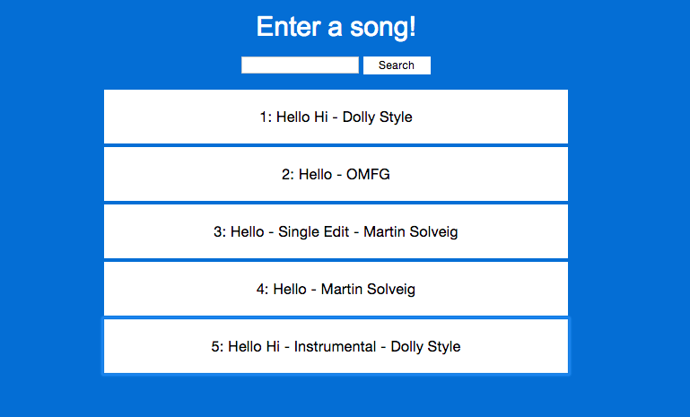

Click on any song to add it to the playlist. The search results should disappear and the clicked song should be in the playlist below the search. The image below is what it should look like if you clicked the first result.



**Voting**

Add a few more songs, try clicking on different results in the list (first result, second result, etc) to make sure the proper ones are being added. Now that you have multiple songs in the list, try voting on them by clicking on them. When voted on, the number next to the song should increase. You should see that whenever a song gets a higher number than another, the one with the higher score will move up in the list, so that the songs are sorted in order of descending score. An example is attached below.

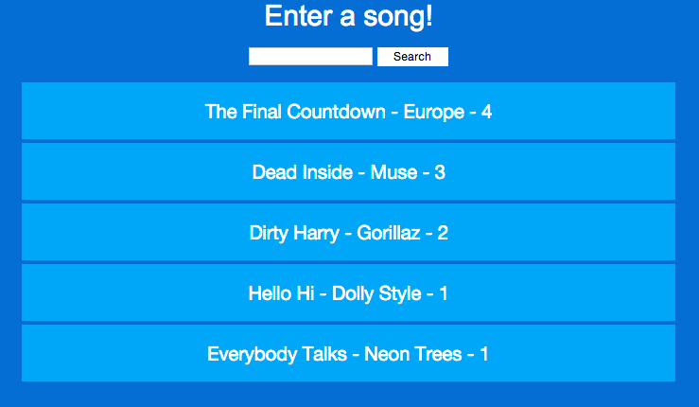

**Multiple Connections**

Use another device to open up the same URL that you entered to view the application on your first device. Ensure that all the information on each device matches – song, song votes, song order, etc. Now try searching for a song on the second device. The search results should NOT appear on the first device. Now try adding a song. The new song SHOULD appear on the other device’s playlist as well. Try voting and rearranging the songs, the playlists on each device should sync up with those changes as well.

**Playing music**

There is a button that should say “Start Playing!”. Once you click on that, a new tab should appear in your browser with the Spotify web app opened to the first song. Listen and enjoy! The next song in the queue should automatically play once the first is done. Currently navigating or refreshing the web page will break the player.

